**Process Explorer v17.06** **:-**

**What is Process Explorer?**

1. **Process Explorer** is a free advanced system tool from Microsoft that shows detailed information about:

* Running processes
* Open files
* CPU & memory usage
* DLLs loaded
* Parent-child process trees

1. **Installation :-**

* Go to the **-** <https://learn.microsoft.com/en-us/sysinternals/downloads/process-explorer>
* After Downloaded extract all files.
* 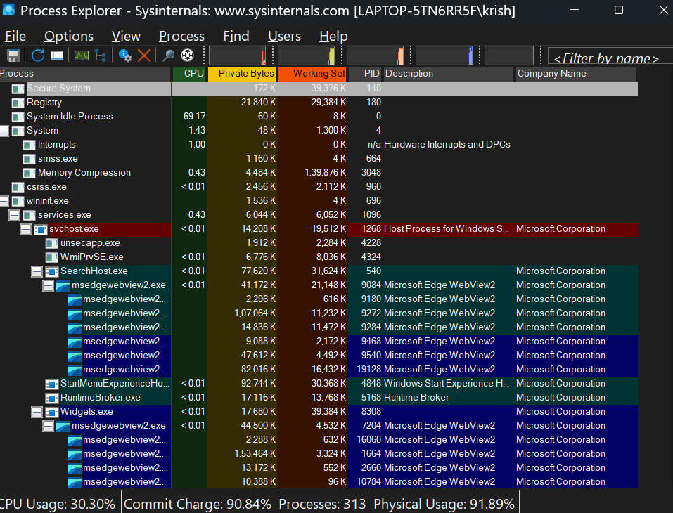The run it by clicking as –

**Use Cases:-**

* Find which app is using a file or folder
* Kill unresponsive or hidden processes
* Check what a process is doing
* Detect malware behavior

**Process Monitor v4.01 :-**

**What is Process Monitor?**

**Process Monitor (ProcMon)** is a free, advanced tool by Microsoft (Sysinternals) used to monitor real-timesystem activity in Windows.

It tracks:

* File system access
* Registry changes
* Process/thread activity
* Network operations

1. **Installation :-**

* Go to the :-https://learn.microsoft.com/enus/sysinternals/downloads/procmon?source=recommendations
* After Downloaded extract all files.
* 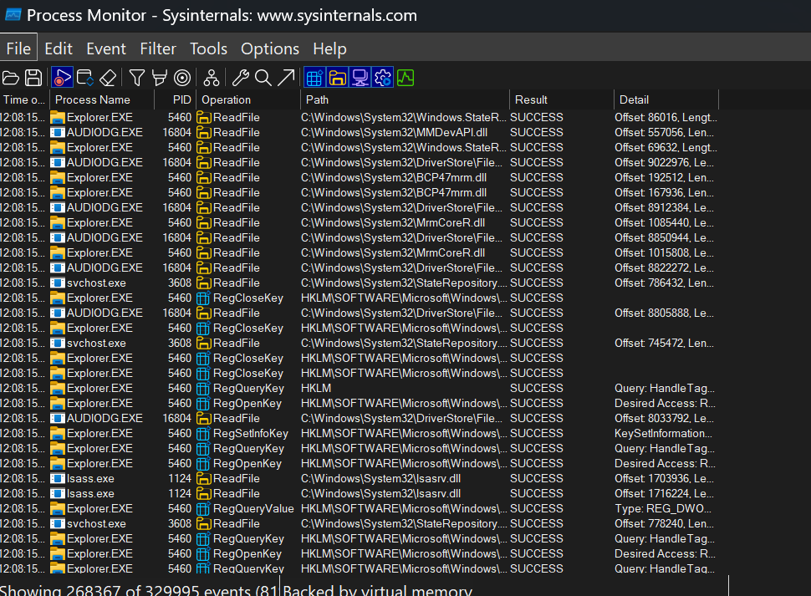Then run it by clicking as :-

**Use Cases:**

* Debug software issues
* Detect malware or suspicious activity
* Find what’s slowing down your PC
* See what a program is doing behind the scenes
* Track why a registry key or file is being accessed

**PsTools :-**

**What is PsTools?**

PsTools is a command-line utility suite from Microsoft Sysinternals that lets you manage remote or local Windows systems without needing to open GUI.

**Download Link:**

🡪 https://learn.microsoft.com/en-us/sysinternals/downloads/pstools

It includes tools like:

Tools Uses

PsExec - Run programs remotely or as admin

PsLoggedOn- See who is logged on.

**Run as –**

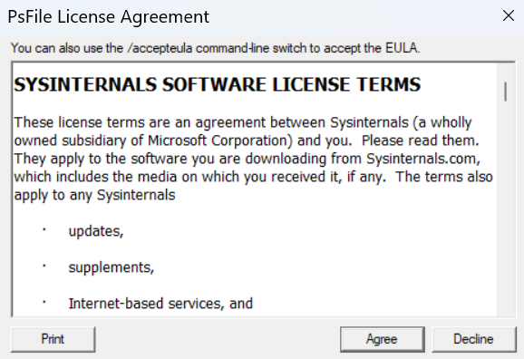

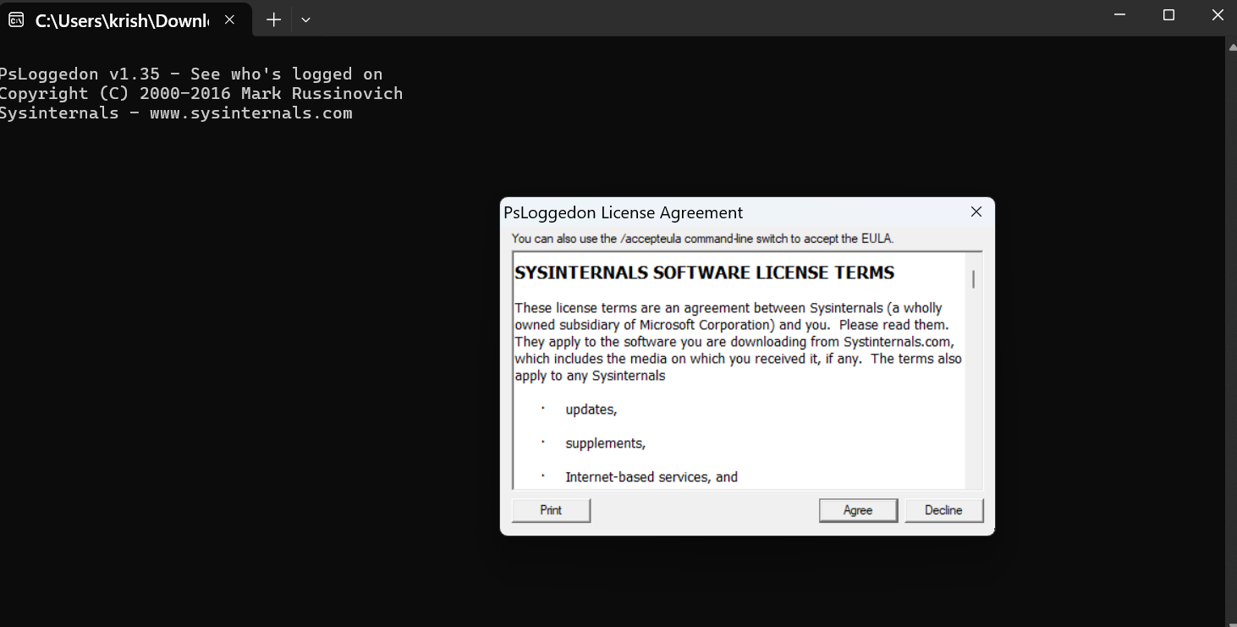

**Steps to create for Microsoft intune portal :-**

**Microsoft Intune Portal:-**

It was used to deploy .exe or .msi file on all VM, PC, client devices at once**.**

**Step 1:** Go to the [Microsoft Intune Free Trial Page](https://signup.microsoft.com/get-started/signup?products=40BE278A-DFD1-470a-9EF7-9F2596EA7FF9&ali=1)

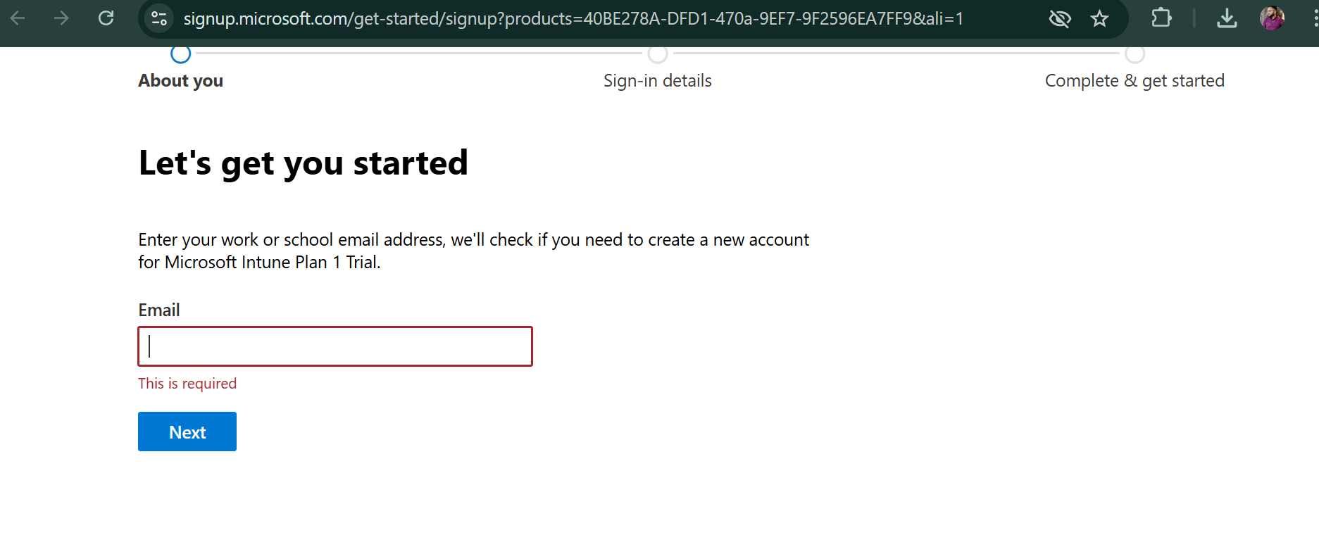

**Step 2:** Enter Your Email Address

**Step 3:** By filling basic details set up your account

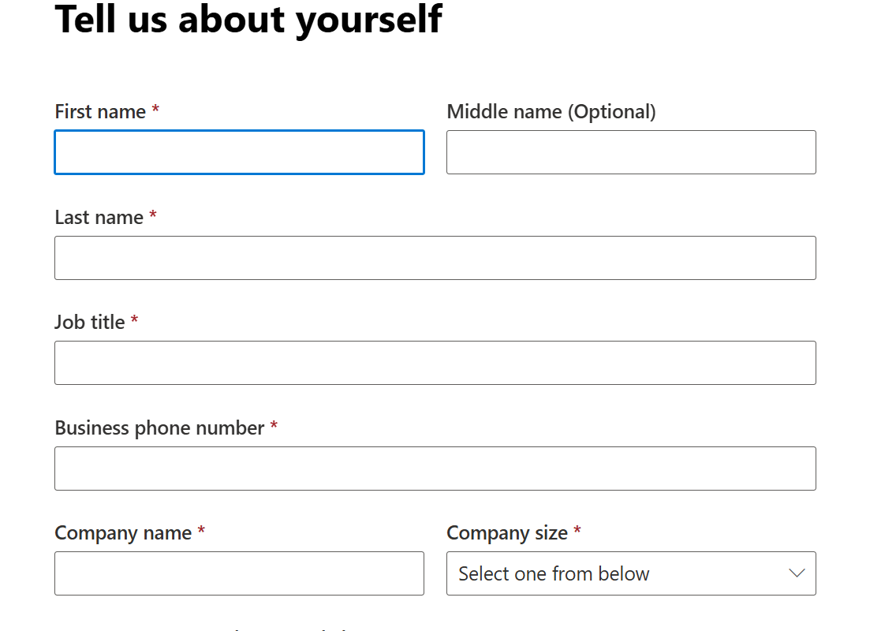

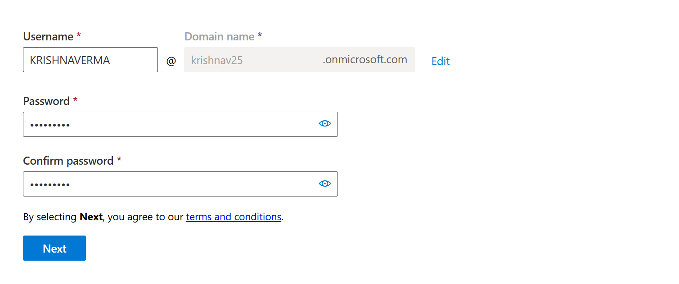**Step 4 :** Admin Account :-

**Step 5:** Use Microsoft Win32 Content Prep Tool

Download: <https://github.com/Microsoft/Microsoft-Win32-Content-Prep-Tool>

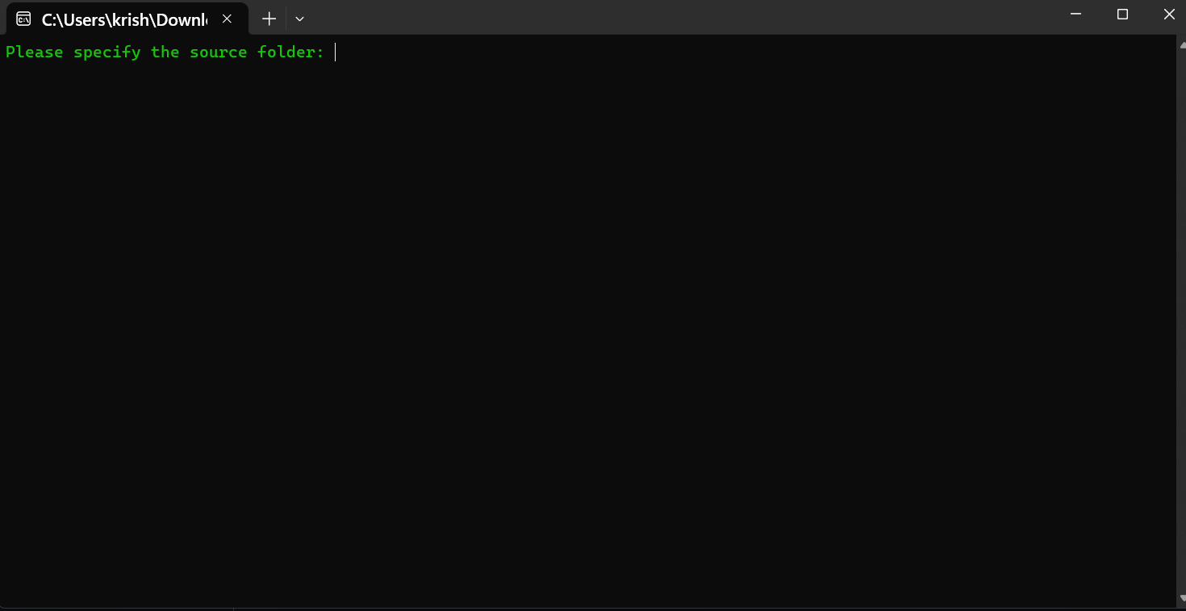**Step 6:-** Click the Downloaded IntuneWinAppUtil.exe file